CrowdStrike Device Remediation (USB v2)

This tip sheet outlines how to restore a computer due to the CrowdStrike major event on 7/19/24.

**Restore a computer**

1. Plug in the USB v2.
2. Reboot the device by holding down the power button.
3. Hold [**F9**] for HP (Hewlett Packard) device or [**F12**] for Dell device while device is rebooting.
4. Select **Boot from USB**.
5. Task Sequence Menu Appears: Click **Next** twice.

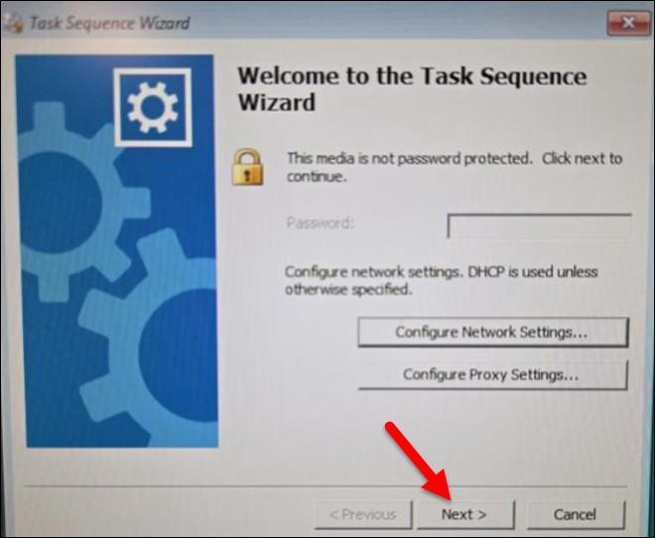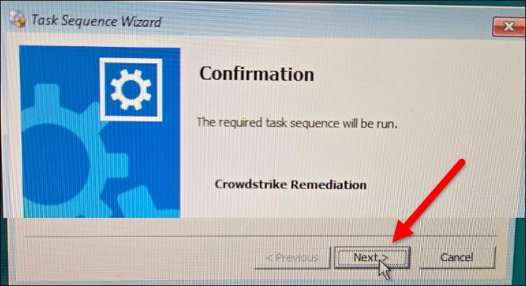

1. A message appears: *“Crowdstrike fix completed successfully, rebooting in 30 seconds.”* The device will then reboot to a working state. Remove the USB.